GE01 Technical Document

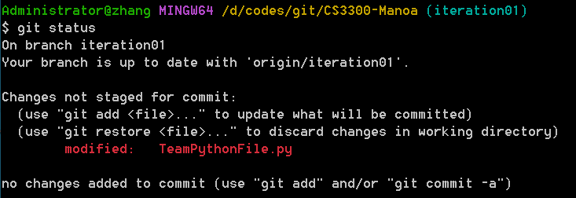

This information marked in red appeared here because I changed the TeamPythonFile.py file in my working directory and I didn’t add and commit to the remote repository yet.

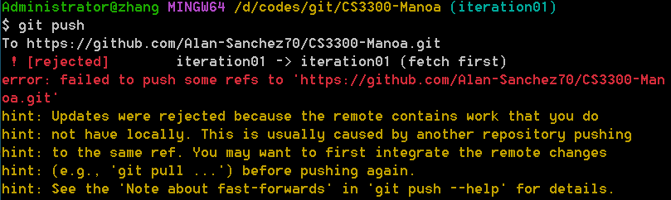

This error appeared because the remote repo has been modified since my last pulling.

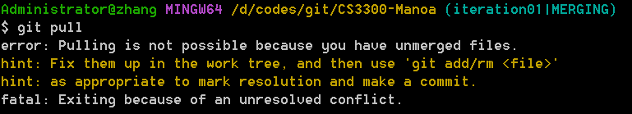

Before this git pull, I had already used “git pull” once, and that gave me a file with conflict for me to make decision. I need to manually modify that file, and then use ‘git add’, ‘git commit’ and ‘git push’ to fix the conflict. Before this conflict got fixed, I got this error when I used this ‘git pull’ command.

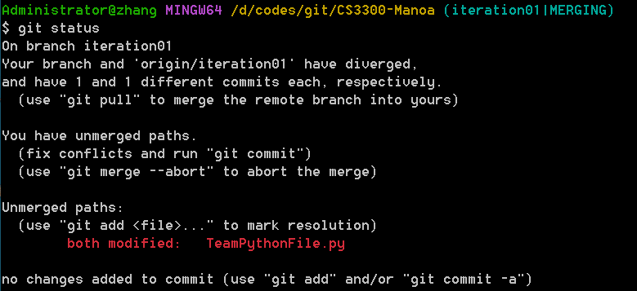

When I used ‘git commit’ command for the TeamPythonFile.py in the stage area, the file in the remote repo had been modified by Bracken, so I got this message.

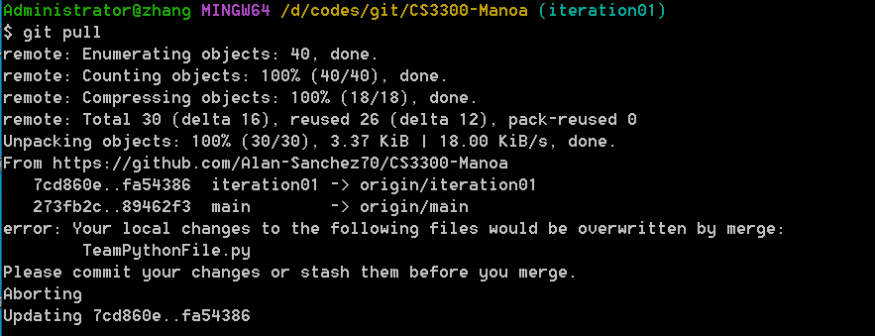

I used ‘git add’ command to add the file to the stage area, but didn’t use ‘git commit’ command. When I used ‘git pull’, this error message popped out.

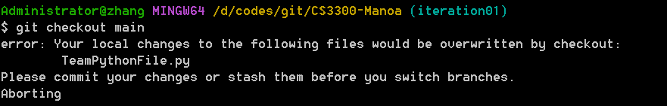

There was the file TeamPythonFile.py which I changed and added to the stage area, but not committed, so I got this error when I switched to the main branch.

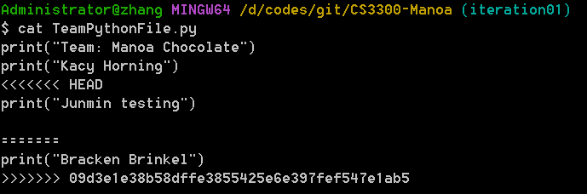

This weird file showed the conflict that Bracken and I both changed the file in the iteration01 brunch. Bracken succeeded to push it to the remote repo, and I got the conflict message. The file was generated by the ‘git pull’ command, and needed to be changed manually.